**MENS PAIRS CUP**

**4 BOWLS TO 18 ENDS**

**CLUB COMPETITION**

**3 DATES ( 2 WEEKDAYS & 1 WEEKEND ) MUST BE GIVEN BY CHALLENGERS TO OPPONENTS TO AGREE A DATE TO PLAY THEIR MATCH.**

**ALL MATCHES TO BE PLAYED BY DATE SHOWN**

**SEMI-FINAL**

**PLAY BY 311stAUGUST**

**2nd ROUND**

**PLAY BY 14th AUG**

**1st ROUND**

**PLAY BY 15th JULY**

**PREM ROUND**

**PLAY BY 31st MAY**

**FINALS WEEKEND**

**15th / 16th SEPT.**

**DAVID LAWRENCE & ROGER KUTCHINSKY**

**V**

**STEPHEN BARNES &**

**GEOFF WOLF**

**-------------------------------------**

**DOUG GREENSTON & HOWARD MOSS**

**V**

**BERNIE DAVIDSON &**

**IAN RHODES**

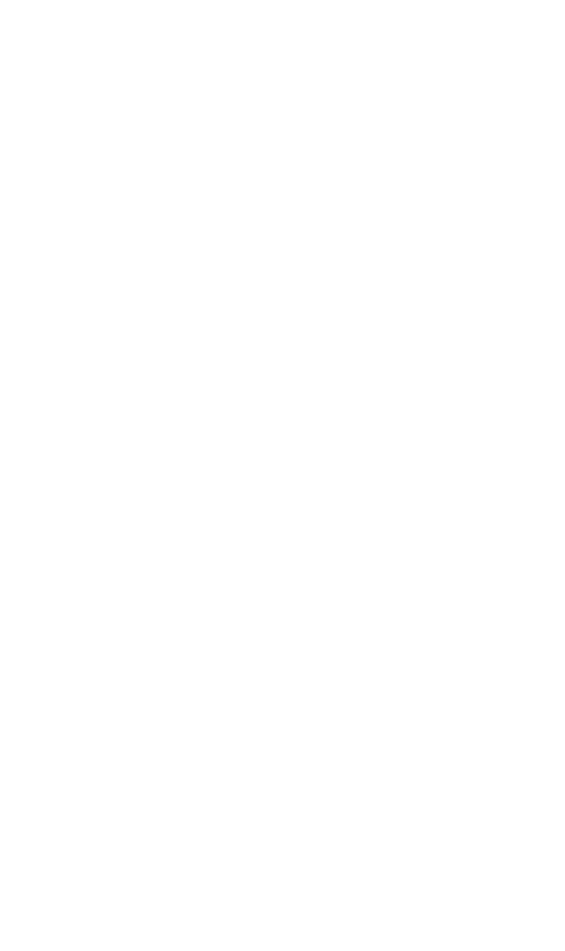

**ALAN BALFOUR & ERIC HILL**

**V**

**LAURENCE PINKUS & BRIAN ASHTON**

**----------------------------------------------------------**

**DAVID LAWRENCE & ROGER KUTCHINSKY**

**MATCH NOT PLAYED**

**GERALD DIAMOND & DAVID PACIFICO**

**-----------------------------------------------------------**

**GARY LUX & MARTIN MOSS**

**V**

**GILBERT BLACKMAN & BENNO STERN**

**-----------------------------------------------------------**

**RAY HARRIS & JOHN FIXLER**

**V**

**STEPHEN BARNES & GEOFF WOLF**

**-------------------------------------------------------------------**

**DOUG GREENSTON & HOWARD MOSS**

**V**

**ERIC CRAVITZ & ALAN KELLER**

**-----------------------------------------------------------**

**WALTER JESSENER & COLIN WAGNER**

**V**

**ALAN SIMONS & DAVID LESSMAN**

**-----------------------------------------------------------**

**EDDIE LANE & ROY DAVIS**

**V**

**BERNIE DAVIDSON & IAN RHODES**

**------------------------------------------------------------------**

**RON SHELLEY & ALAN KRISMAN**

**V**

**FRANK MANCHES & NEIL KAUFMAN**

**DAVID LAWRENCE & ROGER KUTCHINSKY**

**V**

**DOUG GREENSTON & HOWARD MOSS**

**ALAN BALFOUR &**

**ERIC HILL**

**V**

**DAVID LAWRENCE & ROGER KUTCHINSKY**

**---------------------------------------------**

**GARY LUX**

**& MARTIN MOSS**

**V**

**STEPHEN BARNES &**

**GEOFF WOLF**

**--------------------------------------**

**DOUG GREENSTON & HOWARD MOSS**

**V**

**WALTER JESSENER &**

**COLIN WAGNER**

**----------------------------------------**

**BERNIE DAVIDSON &**

**IAN RHODES**

**V**

**RON SHELLEY &**

**ALAN KRISMAN**

**LAURENCE PINKUS & BRIAN ASHTON**

**V**

**PHILIP NORMAN & ROGER NEVILLE**

**------------------------------------------------------------**

**GERALD DIAMOND & DAVID PACIFICO**

**V**

**VICTOR FOX & RAY OSBORNE**

**------------------------------------------------------------**

**GILBERT BLACKMAN &BENNO STERN**

**V**

**EDDIE BORDOLEY & LESLIE GOLD**

**--------------------------------------------------------------**

PLEASE NOTE IF YOU ARE UNABLE TO PLAY YOUR MATCH BY THE REQUIRED DATE YOU MUST INFORM

THE COMPETITION SECRETARY.

COLIN WAGNER

**COMPETITION WINNERS =**

**DOUG GREENSTON & HOWARD MOSS SCORE = 24 -9**